**Assignment -1**

Python Programming

|  |  |
| --- | --- |
| Assignment Date | 19 September 2022 |
| Student Name | Jeyaharini VJ |
| Student Roll Number | 211419104117 |

**Question-1:**

1. Split this string

|  |
| --- |
| **Solution:** |
|  | s = "Hi there Sam!"  print(s.split()) |
|  |  |
|  |  |
|  |  |
|  |  |
|  |  |
|  |  |
|  |  |
|  |  |

**Question-2:**

## 2. Use .format() to print the following string.

### Output should be: The diameter of Earth is 12742 kilometers.

|  |
| --- |
| **Solution:** |
|  |  |
|  | planet = "Earth"  diameter = 12742  print(f"The diameter of {planet} is {diameter} kilometers.") |
|  |  |
|  |  |
|  |  |
|  |  |
|  |  |
|  |  |

**Question-3:**

3. In this nest dictionary grab the word "hello"

|  |
| --- |
| **Solution:** |

d = {'k1':[1,2,3,{'tricky':['oh','man','inception',{'target':[1,2,3,'hello']}]}]}

print(d['k1'][3]["tricky"][3]['target'][3])

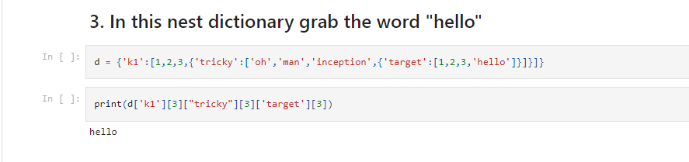

**Question-4:**

# Numpy

|  |
| --- |
| **Solution:** |

**import** numpy **as** np

## 4.1 Create an array of 10 zeros?

## 4.2 Create an array of 10 fives?

|  |
| --- |
| **Solution:** |

arr0 **=** [0] **\*** 9

print (arr0)

[0, 0, 0, 0, 0, 0, 0, 0, 0]

array**=**np**.**ones(10)**\***5

print("An array of 10 fives:")

print(array)

An array of 10 fives:

[5. 5. 5. 5. 5. 5. 5. 5. 5. 5.]

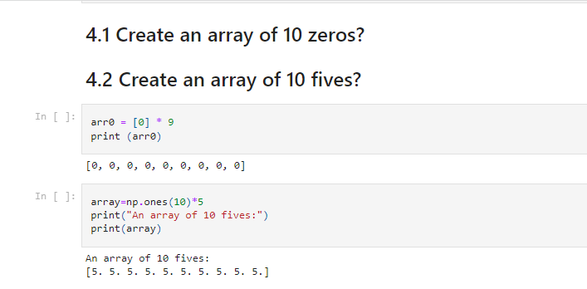

**Question-5:**

## 5. Create an array of all the even integers from 20 to 35

|  |
| --- |
| **Solution:** |

**import** numpy **as** np

array**=**np**.**arange(20,36,2)

print(array)

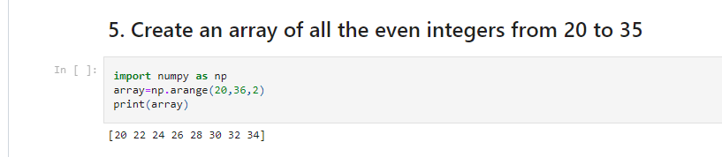

**Question-6:**

## 6. Create a 3x3 matrix with values ranging from 0 to 8

|  |
| --- |
| **Solution:** |

np**.**arange(0,9)**.**reshape((3,3))

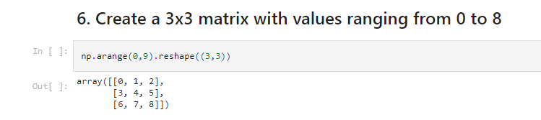

**Question-7:**

## 7. Concatenate a and b

## a = np.array([1, 2, 3]), b = np.array([4, 5, 6])

|  |
| --- |
| **Solution:** |

a **=** np**.**array([1,2,3])

b **=** np**.**array([4,5,6])

np**.**concatenate((a,b))

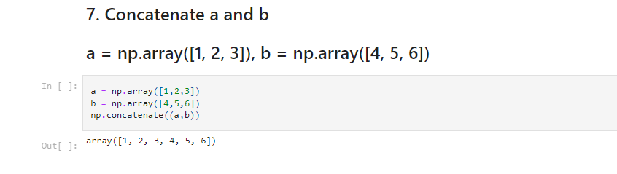

**Question-8:**

# Pandas

## 8. Create a dataframe with 3 rows and 2 columns

|  |
| --- |
| **Solution:** |

**import** pandas **as** pd

data **=** {'Name':['Tom', 'nick', 'krish', 'jack'], 'Age':[20, 21, 19, 18]}

df **=** pd**.**DataFrame(data)

print(df)

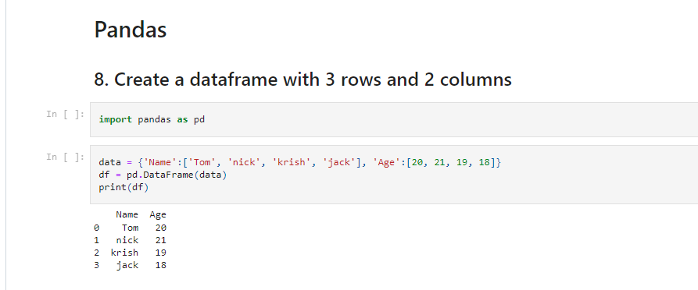

**Question-9:**

## 9. Generate the series of dates from 1st Jan, 2023 to 10th Feb, 2023

|  |
| --- |
| **Solution:** |

dates **=**pd**.**date_range('2023-01-01','2023-02-10')

pd**.**Series(data**=**dates)

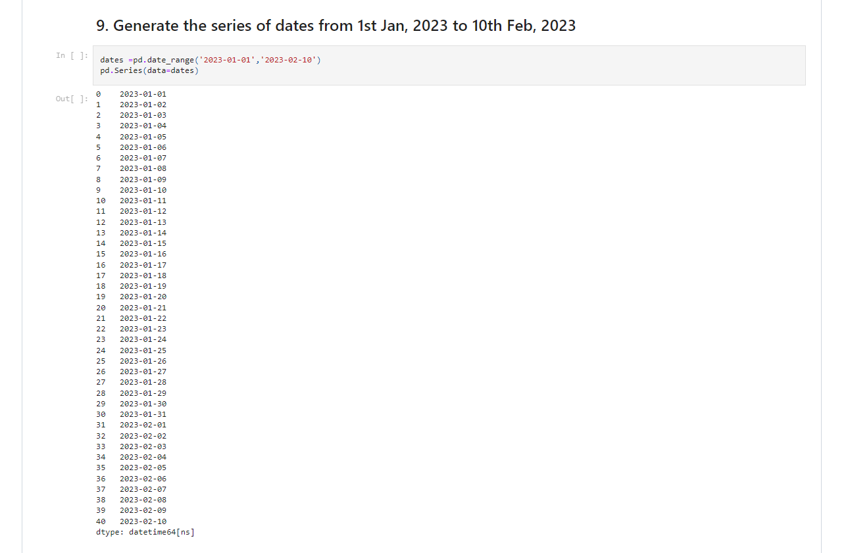

**Question-10:**

## 10. Create 2D list to DataFrame

lists = [[1, 'aaa', 22], [2, 'bbb', 25], [3, 'ccc', 24]]

|  |
| --- |
| **Solution:** |

lists **=** [[1, 'aaa', 22], [2, 'bbb', 25], [3, 'ccc', 24]]

values**=**lists

pd**.**DataFrame(values)

